**Department of Computing**

**Name: Unsha Aftab**

**CMS ID: 217673**

**CS-213: Advanced Programming**

**Class: BSCS 7AB**

**Lab 08: React JS**

**Date: 07 November, 2019**

**Time: 10:00-01:00pm & 02:00-05:00pm**

**Instructor: Dr. Sidra Sultana**

**Lab Engineer: Ms. Ayesha Asif**

**Task 01:**

**CODE:**import React from 'react';

import logo from './logo.svg';

import './App.css';

class App extends React.Component {

constructor(props) {

super(props);

this.state = {

brand: "Ford",

model: " Mustang ",

color: "red",

year: 1964

};

}

changeColor = () => {

this.setState({color: "blue"});

}

render() {

return (

<div>

<h1>My {this.state.brand}</h1>

<p>

It is a {this.state.color}

{this.state.model}

from {this.state.year}.

</p>

<button

type="button"

onClick={this.changeColor}

>Change color</button>

</div>

);

}

}

export default App;

**OUTPUT:  
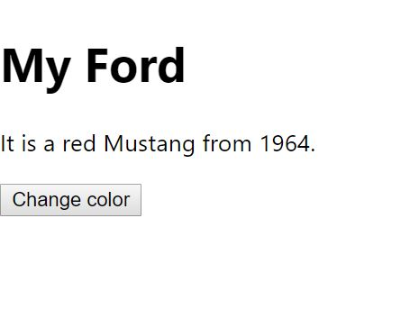**

**Task 2:**

**Code:**

import React from "react";

import ReactDOM from "react-dom";

class TimerInput extends React.Component {

render() {

return (

<div style={{marginLeft:100}}>

<h3>Input your desired time</h3>

<input type="number" value={this.props.value} onChange={this.props.handleChange} required />

</div>

);

}

}

class Timer extends React.Component {

render() {

return (

<div>

<h1 style={{ fontSize: 100, marginLeft:100 }}>{this.props.value}:{this.props.seconds}</h1>

</div>

);

}

}

class StartButton extends React.Component {

render() {

return (

<div style={{ marginLeft: 130 }}>

<button className="btn btn-lg btn-success" disabled={!this.props.value} onClick={this.props.startCountDown}>Start</button>

</div>

);

}

}

class App extends React.Component {

constructor(props) {

super(props);

this.state = {

seconds: '00',

value: '',

isClicked : false

}

this.handleChange = this.handleChange.bind(this);

this.startCountDown = this.startCountDown.bind(this);

this.tick = this.tick.bind(this);

}

handleChange(event) {

this.setState({

value: event.target.value

})

}

tick() {

var min = Math.floor(this.secondsRemaining / 60);

var sec = this.secondsRemaining - (min * 60);

this.setState({

value: min,

seconds: sec,

})

if (sec < 10) {

this.setState({

seconds: "0" + this.state.seconds,

})

}

if (min < 10) {

this.setState({

value: "0" + min,

})

}

if (min === 0 & sec === 0) {

clearInterval(this.intervalHandle);

}

this.secondsRemaining--

}

startCountDown() {

this.intervalHandle = setInterval(this.tick, 1000);

let time = this.state.value;

this.secondsRemaining = time * 60;

this.setState({

isClicked : true

})

}

render() {

const clicked = this.state.isClicked;

if(clicked){

return (

<div>

<div className="row">

<div className="col-md-4"></div>

<div className="col-md-4">

<Timer value={this.state.value} seconds={this.state.seconds} />

</div>

</div>

</div>

);

}else{

return (

<div>

<div className="row">

<div className="col-md-4"></div>

<div className="col-md-4">

<TimerInput value={this.state.value} handleChange={this.handleChange} />

<Timer value={this.state.value} seconds={this.state.seconds} />

<StartButton startCountDown={this.startCountDown} value={this.state.value} />

<br/>

<br/>

</div>

</div>

</div>

);

}

}

}

const rootElement = document.getElementById("root");

ReactDOM.render(<App />, rootElement);

**Output:**

